AWS Launching and configuring an Amazon EC2 Instance

Adhvitha Sivaganesh| CCNP

Purpose:

In this lesson, our goal was to create a webserver for a company to introduce a new product called BitBanger. We had to configure the webserver with it being a Linux machine, an Apache HTTP server, relatively inexpensive and publicly accessible. We got to launch and configure the EC2 console by updating the security groups, creating rules, and resizing the instance. Overall, in this lab we learned to launch an Amazon EC2 instance with specific configurations to create a webserver for the organization.

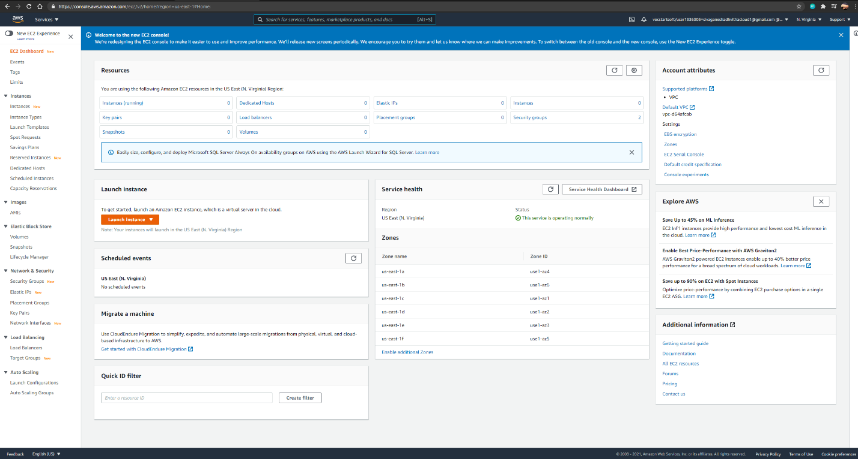

* I went into the EC2 dashboard through the AWS console and launched an instance.

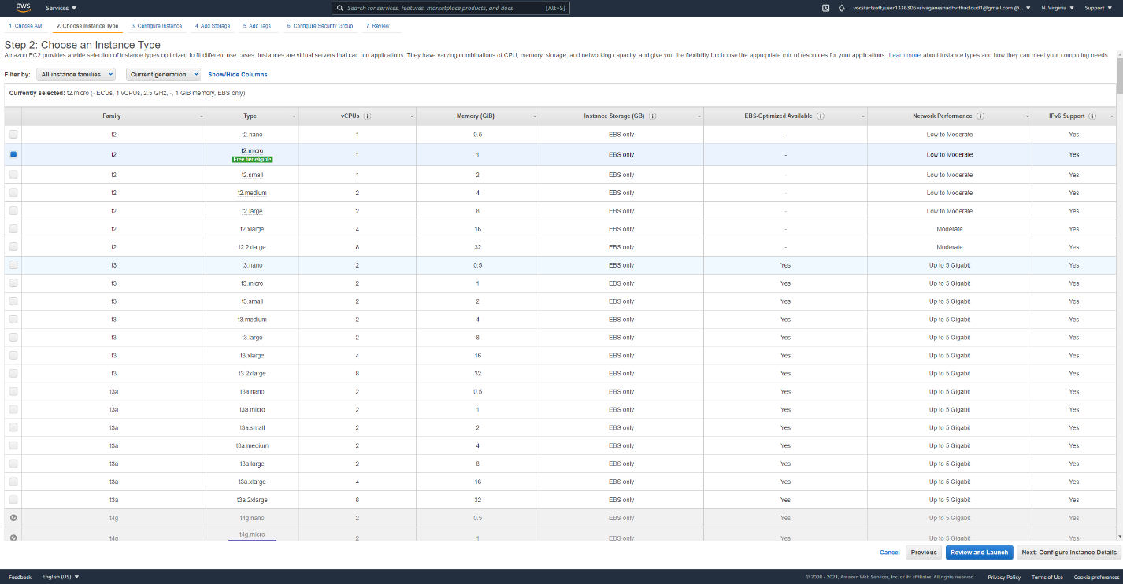

* After I entered the instance, I saw the variety of AMIs located and selected the “Amazon Linus 2 AMI (HVM) and then selected the t2.micro.instance.

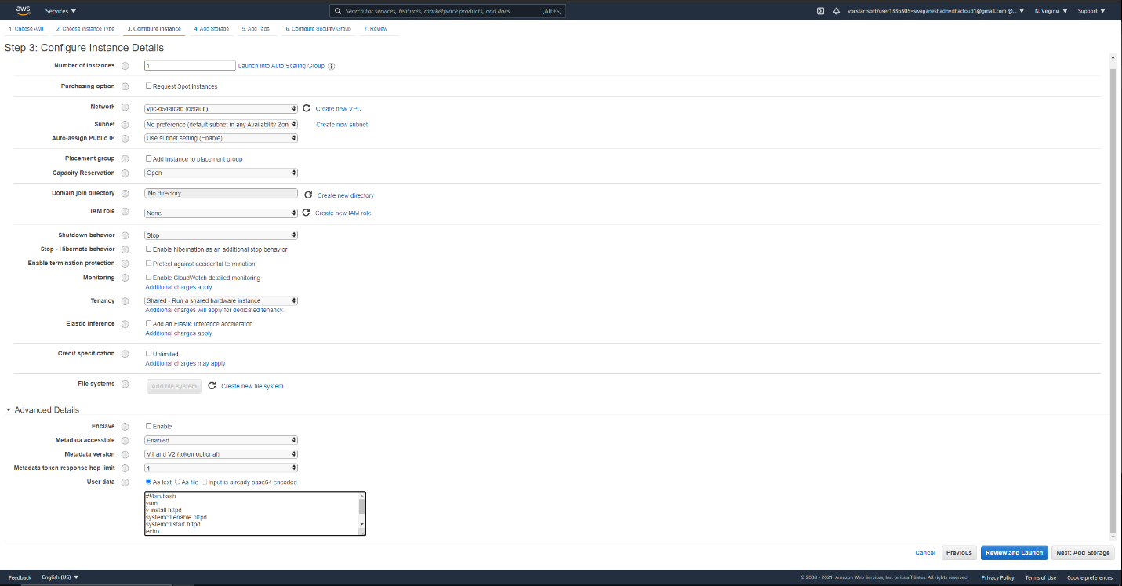

* When I entered the instance details page, I kept the default settings and then went to the advanced details section and entered the commands which provides the codes when a computer starts up.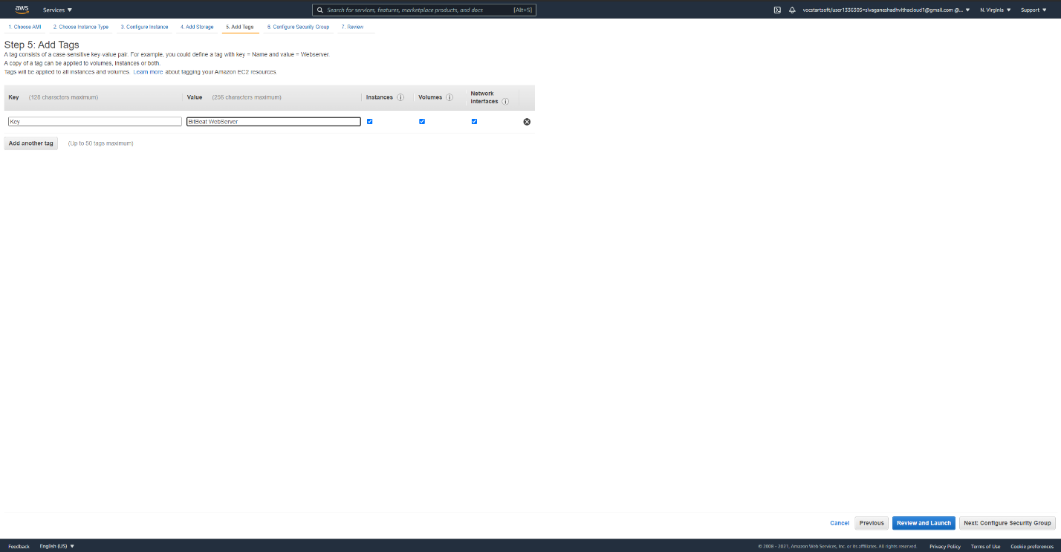
* After entering the code, I went to the storage tab and went forward with the default settings to the tags portion. I added a tag with the key as name and the value as BitBeat WebServer.

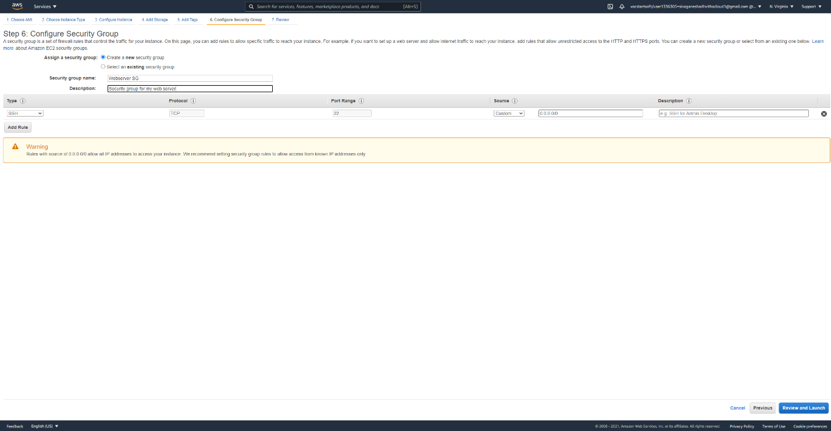

* 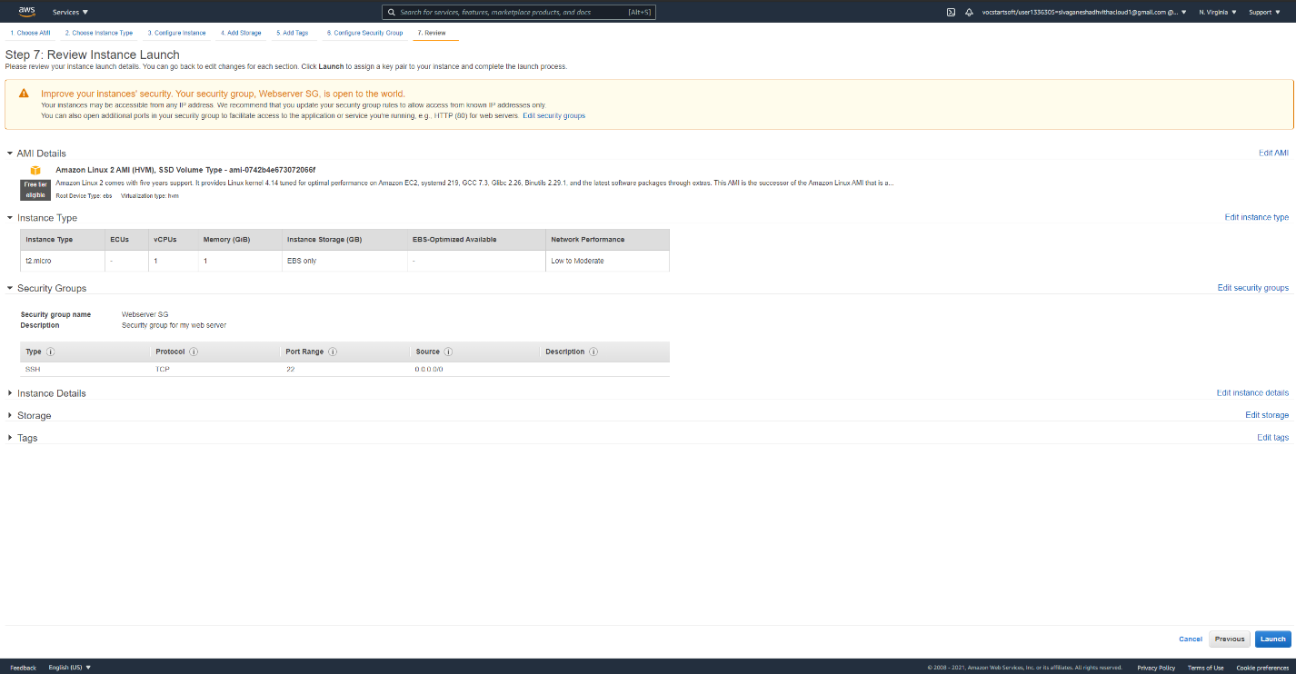I went into to security group tab to create a new one with the name Webserver SG and the description “Security group for my web server”.
* 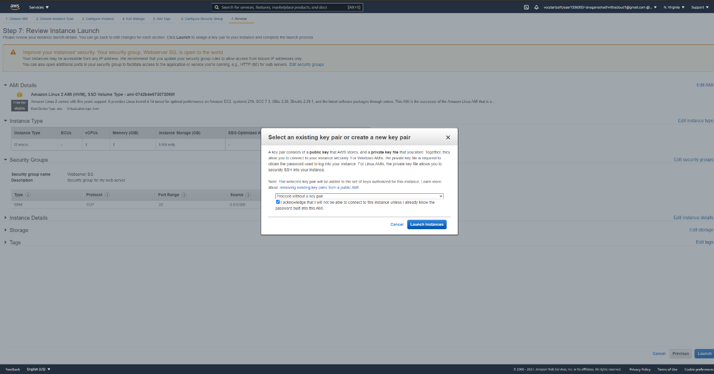After that I went and reviewed the details for the instance and in the key pair model displays, I selected Proceed without a key pair and acknowledged the statement before launching the instance.

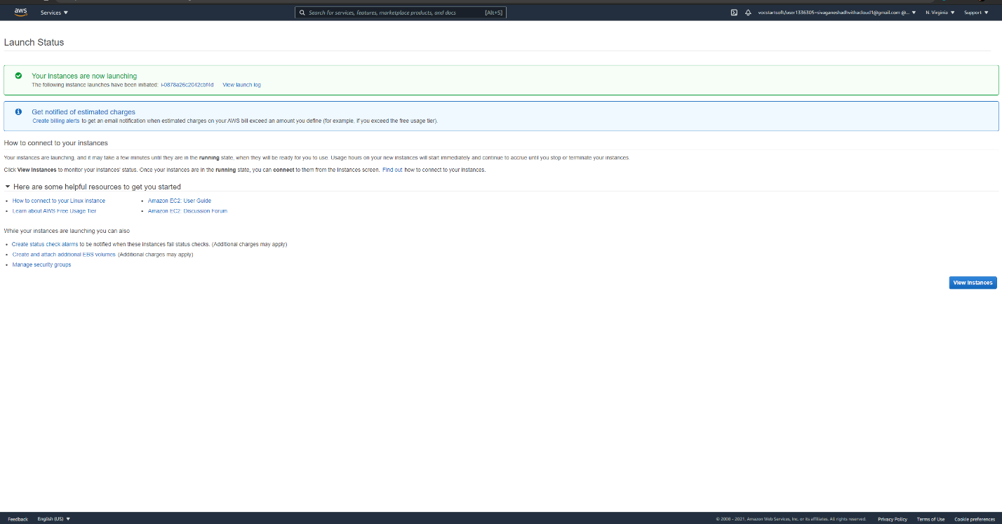

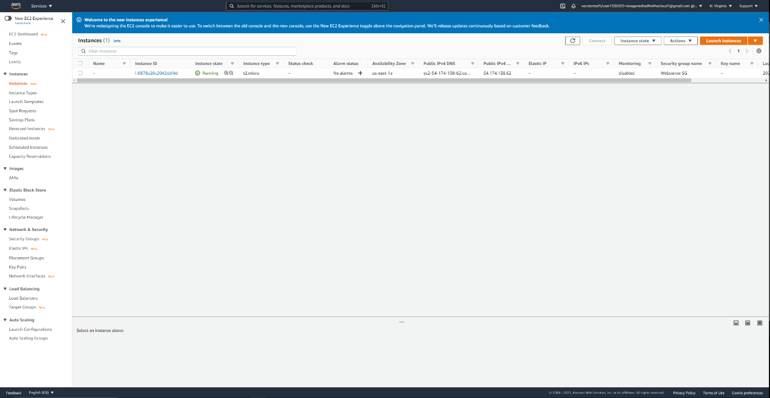

* 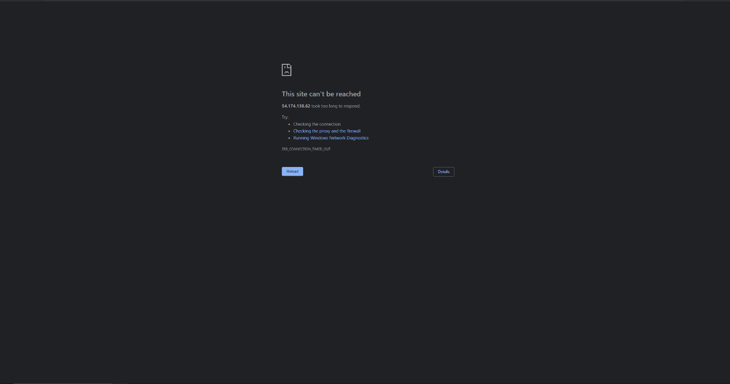Once I accepted the terms, the instance was launched and I went to the launch status page to double check if the instance was running
* I attempted to open the webpage from the IPv4 address of the instance and found out that it wouldn’t work because of permission reasons on AWS cloud.

Problems:

One problem I encountered was when I was trying to get into the BitBeat Webserver. I typed in the public IPv4 address and it took a while to load before it mentioned that the site can’t be reached. I tried troubleshooting it by updating my security groups and making sure that all of my rules were set in the inbound tab. I also created the new inbound HTTP rule that created an entry for both of the IPv4 addresses as well as the IPv6 address. I tried to launch the webpage again after adding the rules and troubleshooting the instance, but the webpage still wouldn’t load. I found out that there was an error being said on my instance mentioning that I do not have permission to access some of the instances. I spoke to my other classmates and found out that it was an error within AWS in my account.

Conclusion:

In this lab, I learned how to configure an Amazon EC2 instance and create a webserver. I got learn about security groups and specific rules for the webserver. I had to update the security groups, test rules, resize an instance, and troubleshoot to attempt to launch the webserver. I did encounter some problems when trying to launch the webpage and found out that it was because of permission issues through my AWS account. In conclusion, I learned the steps to provision and launch an Amazon EC2 instance with the right AMI to create a webpage.